QT Practice Project

Place the following components in your UI. Text in quotes is the text for the widget.

1. Pushbutton “PUSH”
2. CheckBox “Option 1”
3. CheckBox “Option 2”
4. RadioButton “AM”
5. RadioButton “FM”
6. GroupBox “Check Boxes”
7. GroupBox “Radio Buttons”

Place the components approximately like this:

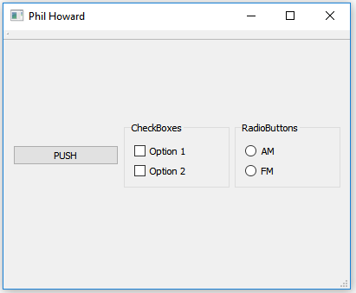

Add a no-argument slot to your main window. Have the code for the slot change the text for Option 1 to “This is a much longer string”.

Connect the “clicked” signal from your button to the new slot.

Setup a layout so that all your widgets are managed by the layout(s), and so that when you click the button to change the text, your layout adjusts the sizes of things so the text is all visible.

Hint: select a widget that contains other widgets then right-click and select “layout” to set the layout for that widget and its children.

Hint 2: The main window is a widget.

